PART A
EXPERIMENT NO. 8
A.1 Aim: - Implement K- Means Clustering

A.2 Prerequisite
- Programming language structure overview

A.3 Outcome
After successful completion of this experiment students will be able to understand Unsupervised Learning.

A.4 Theory:

- K-Means Clustering is an unsupervised learning algorithm that is used to solve the clustering problems in machine learning or data science.
- K-Means Clustering is an Unsupervised Learning algorithm, which groups the unlabeled dataset into different clusters.
- Here K defines the number of pre-defined clusters that need to be created in the process, as if K=2, there will be two clusters, and for K=3, there will be three clusters, and so on.
- It is a centroid-based algorithm, where each cluster is associated with a centroid. The main aim of this algorithm is to minimize the sum of distances between the data point and their corresponding clusters.

Procedure:

The algorithm takes the unlabeled dataset as input, divides the dataset into k-number of clusters, and repeats the process until it does not find the best clusters. The value of k should be predetermined in this algorithm.
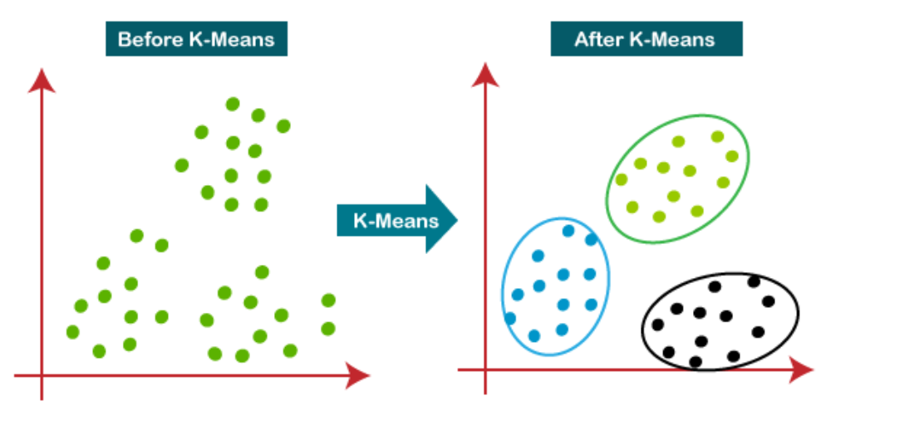

Present it to the instructor/class.

(PART - B)

(TO BE COMPLETED BY STUDENTS)

(Students must submit the soft copy as per following segments within two hours of the practical. The soft copy must be uploaded on the Blackboard or emailed to the concerned lab in charge faculties at the end of the practical in case there is no Black board access available)

Roll.No.: B091 | Name: Yash Korla
Sem/Year: 3rd Year (Semester 5) | Batch: B2
Date of Experiment: 15-09-2023 | Date of Submission:
Grade:

B.1: Procedure of performed experiment

B.2: Observations and Learning’s:
(Students are expected to comment on the output obtained with clear observations and learning for each task/ sub part assigned)

B.3: Conclusion:
(Students must write the conclusion as per the attainment of individual outcome listed above and learning/observation noted in section B.2)

